WaterMaker IoT Pressure Monitor: User Guide

Welcome
Welcome to the WaterMaker IoT Pressure Monitor, an innovative device designed for the MAB WaterMaker system (http://watermaker.se). While the MAB WaterMaker system is fully functional with its incorporated analog devices, this device adds an extra layer of monitoring and convenience, allowing you to monitor and receive alerts even when away from the watermaker's control panel, like in the cockpit of the vessel. This user guide will provide you with detailed information about the setup, use, and how to integrate this device into your monitoring system.

Device Functionality
The MAB WaterMaker is equipped with all indicators for its operation in a safe manner. However, it is convenient to regularly monitor the pressures while it works to ensure proper functioning. This can be done by looking at the watermaker control panel or remotely with this device.
The device is equipped with two high-precision pressure sensors. These sensors are responsible for measuring and recording the pressure in your water purification system. The sensors operate in different pressure ranges:
- The first sensor monitors low-pressure circuits and can measure values in the range of 0 to 4 bar.
- The second sensor takes care of high-pressure circuits and can record values in the range of 0 to 70 bar.

Operating Modes
The device can operate in two main modes: Station and AP (Access Point).
- Station Mode: In this mode, the device connects to an existing WiFi network. You can configure the device to connect to your home WiFi network or to a specific network on your vessel. If for some reason it cannot connect to the preconfigured network (for example, if the network is not available or incorrect credentials were entered), the device will initiate and temporarily create a WiFi network called 'watermaker_config'. This will allow you to select or reconfigure the WiFi network directly from the device. Also, in this mode, the software will automatically search for the SignalK server, simplifying integration with boat instrumentation systems.
- AP (Access Point) Mode: In this mode, the WaterMaker IoT Pressure Monitor creates its own WiFi network called 'watermaker'. This mode is useful when you do not have access to an existing WiFi network. You can configure a password for this WiFi network to ensure secure access. You can access the device in this mode through the hostname 'watermaker.local' or via the default IP address '192.168.4.1'.

Remote Monitoring
A standout feature of this device is its ability to allow remote monitoring of your WaterMaker system. This means you can check the status of your system in real time from any location. Whether you are inside your vessel or on land (if you have configured the router for remote access), you can access the pressure data and ensure that your system is functioning correctly.

Web Interface for Pressure Monitoring
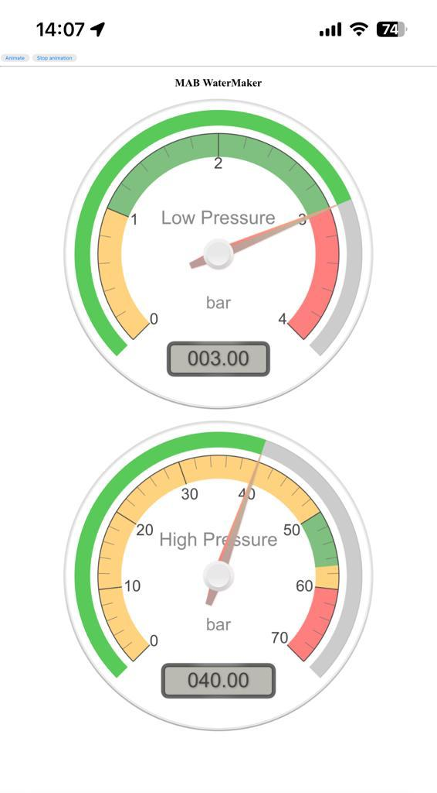
Once you access watermaker.local through your web browser, the interface will show two radial gauges, each displaying a different aspect of the watermaker's operation:

Low Pressure Gauge
- Range: 0 to 4 bar
- Color-Coded Highlights:
  - Orange Zone (0-1 bar): Low-pressure warning.
  - Green Zone (1-3 bar): Normal operating pressure range.
  - Red Zone (3-4 bar): High-pressure warning.

High Pressure Gauge
- Range: 0 to 70 bar
- Color-Coded Highlights:
  - Orange Zone (0-50 bar): Preparatory pressure range.
  - Green Zone (50-57 bar): Normal operating pressure range.
  - Orange Zone (57-60 bar): Transition or caution area.
  - Red Zone (60-70 bar): High-pressure warning.
These gauges are designed to provide clear and intuitive feedback on the system's status, with green zones specifically marking the ideal operating pressures. Users can conveniently monitor the watermaker's performance and ensure it operates within safe and efficient pressure ranges. Data is received in the SignalK Server, consequently it can be displayed with KIP or with third-party apps such as WillHelm SK.

Sensor configuration
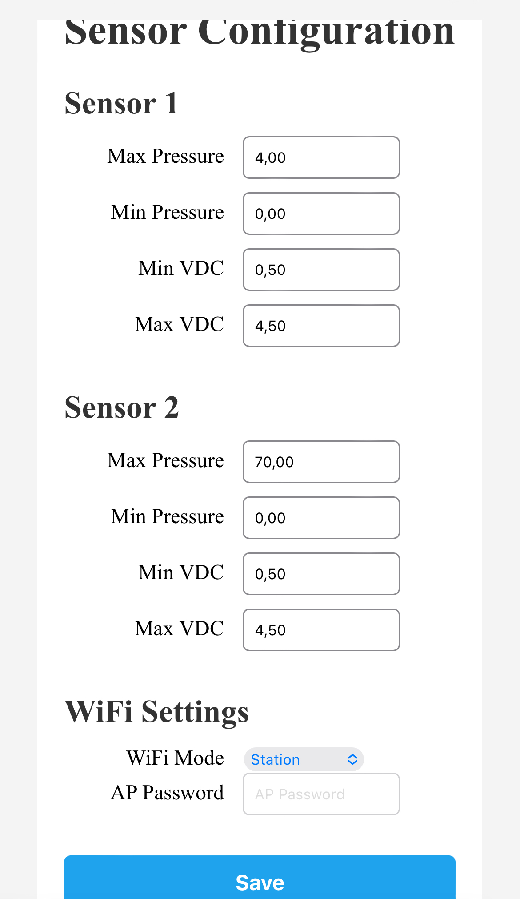
The sensors used in the WaterMaker IoT Pressure Monitor must meet certain specifications to function properly with the device. Here are the key specifications they should adhere to:
- Power Supply: The sensors should be capable of operating with a 5VDC power source. This means they should be able to function with a voltage of 5 volts of direct current.
- Maximum Signal Voltage: The sensor should be able to provide a voltage signal within the range of 0 to 4.5 volts, depending on the maximum pressure expected to be measured. This ensures that the sensor can effectively transmit pressure information to the WaterMaker IoT Pressure Monitor.
- Threaded Connection: For sensor installation, a high-pressure "T" with a male G1/4 thread, a female G1/4 thread, and a female thread that matches the sensor's thread should be used. This ensures a proper and sealed connection for accurate pressure measurement.
As for sensor configuration, it is done on the configuration page, which can be accessed in two ways:
- From the wheel icon in the upper-right corner of the "gauges" screen in the web interface of the WaterMaker IoT Pressure Monitor.
- Directly by entering the web address "watermaker.local/config" in a web browser.
On this configuration page, users can adjust sensor parameters such as pressure ranges to match the specific characteristics of the sensor they are using. This ensures that the sensors are correctly configured to provide accurate measurements and adapt to the expected operating conditions.

Indicator Lights
Red LED (Status Indicator)
- Solid On: The red LED remains solidly lit when the device is powered. This indicates that the device is receiving power and is operational.
- LED Off: The red LED turns off when the device successfully establishes a connection to the network. This signifies that the device is connected to a network, either through Station Mode (connecting to an existing WiFi network) or Access Point (AP) Mode (creating its own WiFi network).
- Blinking (Flashing): The red LED blinks or flashes each time data is transmitted to the SignalK server. This serves as a visual confirmation that the device is actively sending pressure data to the SignalK server, indicating its functionality and data communication activity.

Integration with SignalK
The device is designed to automatically connect to the SignalK server when in Station mode. SignalK is an open-source standard for boat navigation that allows the integration of data from different systems and sensors. The WaterMaker IoT Pressure Monitor sends pressure data to the SignalK server via port 4210. This allows you to use SignalK-compatible monitoring applications to visualize and analyze the pressure data.

SignalK Configuration
The WaterMaker IoT Pressure Monitor is designed to automatically connect to the SignalK server when in Station mode. The device will send data through port 4210 of the SignalK server. To configure the SignalK server and receive data from the device, follow these steps:
- Access the SignalK Web Interface: Open the SignalK web interface from your web browser and make sure you are logged into your SignalK account if necessary.
- Navigate to Connection Configuration: In the SignalK web interface, look for the connection configuration section or data sources. This is usually found in server settings or a similar configuration menu.
- Add a New UDP Connection: Within the connection configuration section, look for the option to add a new UDP connection. It may have a name like "Add Connection" or similar.
- Configure the UDP Connection:
  - Data Type: Specify "SignalK" as the expected data type.
  - UDP Port: Enter "4210" as the UDP port number to which the WaterMaker IoT Pressure Monitor will send data.
- Save the Configuration: Once you have specified the data type as "SignalK" and configured the UDP port as "4210", make sure to save the settings. You will usually find a button or an option to save changes.
- Verify the Configuration: After saving the settings, verify that the UDP connection is active and working correctly. You can check the SignalK web interface to confirm that the data is being received and processed according to the SignalK standard.
By following these steps, you will have correctly set up a UDP connection in SignalK to receive data from the WaterMaker IoT Pressure Monitor on port 4210. This will allow SignalK to interpret and process the pressure data according to the SignalK standard, facilitating its visualization and analysis in SignalK-compatible applications or on the SignalK web interface.
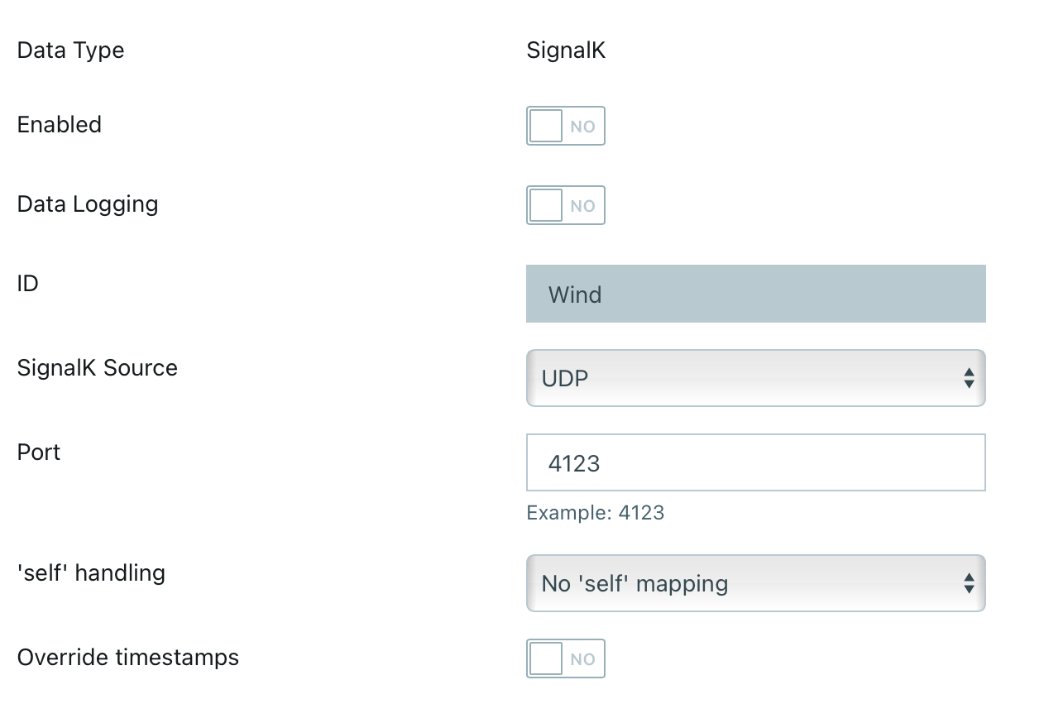

Custom Alerts
In addition to real-time monitoring, the WaterMaker IoT Pressure Monitor allows you to set up custom alerts. You can set specific pressure thresholds and receive instant notifications in case abnormal pressure conditions are detected. These alerts provide an additional layer of safety and allow you to take immediate action in case of issues with your WaterMaker system. The configuration of the alerts is done on the SignalK server with the necessary plugins or for advanced users with Node-red.

Access Point (AP) Password Reset
If you forget the configured password for the AP (Access Point) mode on the WaterMaker IoT Pressure Monitor, you can reset it to the default factory password, which is "12345678". Follow these steps to do so:
- Locate the physical reset button on the WaterMaker IoT Pressure Monitor device.
- Briefly press the reset button once. It is not necessary to hold it pressed for a long time.
- After pressing the reset button, the AP password will automatically reset to the default password "12345678".
- You can now connect to the AP mode using the default password "12345678".
Remember that, after resetting the AP password, it is advisable to set a new secure password to ensure the security of your network. You can do this through the device's web configuration interface.

.

